Lab Assignment Task
JavaScript Introduction
- Create a simple HTML page and add a <script>tag within the page.
Ans:- 
- Write JavaScript code to display an alert box with the message "Welcome to JavaScript!" when the page loads.
Ans:-
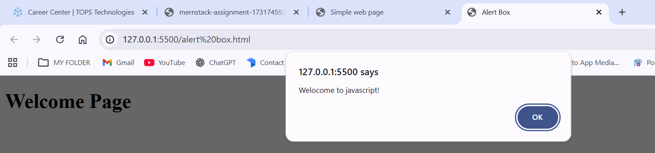
Variables and Data Types
- Write a JavaScript program to declare variables for different data types (string, number, Boolean, null, and undefined).
Ans:- Same 2
- Log the values of the variables and their types to the console using console.log(). Ans:- 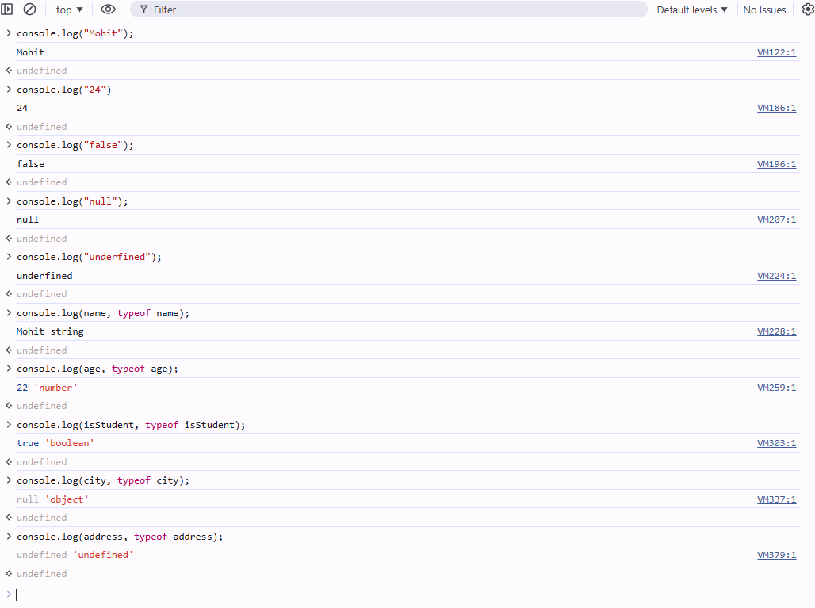
JavaScript Operators
- Create a JavaScript program to perform the following:
• Add, subtract, multiply, and divide two numbers using arithmetic operators.
• Use comparison operators to check if two numbers are equal and if one number is greater than the other.
• Use logical operators to check if both conditions (e.g., a > 10and b < 5)are true.
Ans:- .
- Arithmetic operators: +, -, *, /
- Comparison operators: === (equal), > (greater than)
- Logical operator: && checks if both conditions are true

Control Flow (If-Else, Switch)
Task 1: • Write a JavaScript program to check if a number is positive, negative, or zero using an if-else statement.
Ans:- It takes input from the user.
- Checks:
- > 0 → Positive
- < 0 → Negative
- Otherwise → Zero

Task 2: • Create a JavaScript program using a switch statement to display the day of the week based on the user input (e.g., 1 for Monday, 2 for Tuesday, etc.).
Ans:- The switch statement matches the number and prints the corresponding day
Lab Assignment
• Task 1: • Write a JavaScript program using a for loop to print numbers from 1 to 10.
Ans:-
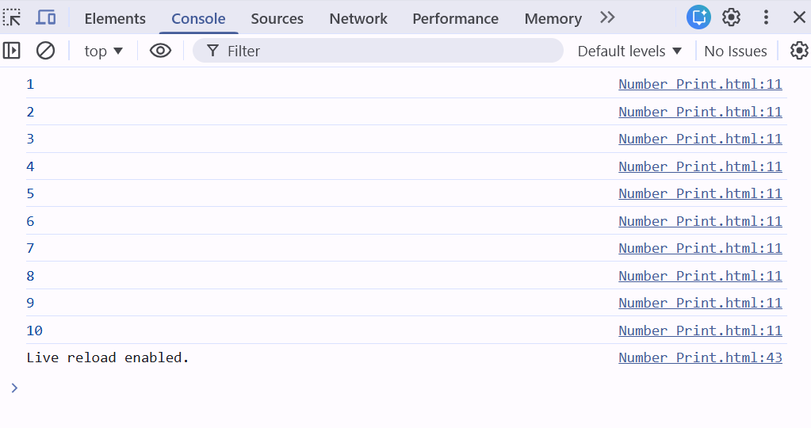
• Task 2: • Create a JavaScript program that uses a while loop to sum all even numbers between 1 and 20.
Ans:- This starts from 2 (first even number), keeps adding even numbers, and stops at 20.
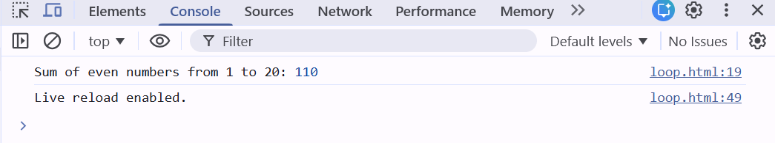
• Task 3: • Write a do-while loop that continues to ask the user for input until they enter a number greater than 10.
Ans:- The do-while loop runs at least once.
It keeps prompting the user until the entered number is greater than 10.
You entered: 5-10

Functions
Lab Assignment
• Task 1: Write a function greet User that accepts a user’s name as a parameter and displays a greeting message (e.g., "Hello, John!").
Ans:-
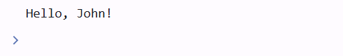
• Task 2: Create a JavaScript function calculate Sum that takes two numbers as parameters, adds them, and returns the result.
Ans:- 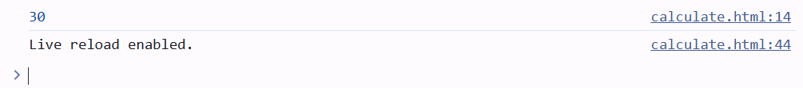
Arrays
Lab Assignment
•Task 1: • Declare an array of fruits (["apple", "banana", "cherry"]). Use JavaScript to: • Add a fruit to the end of the array. • Remove the first fruit from the array. • Log the modified array to the console.
Ans:- 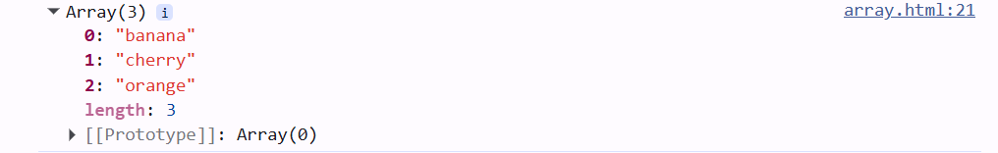
• Task 2: • Write a program to find the sum of all elements in an array of numbers.
Ans:-

Objects
Lab Assignment
• Task: • Create a JavaScript object car with properties brand, model, and year. Use JavaScript to: • Access and print the car’s brand and model. • Update the year property. • Add a new property color to the car object.
Ans:-
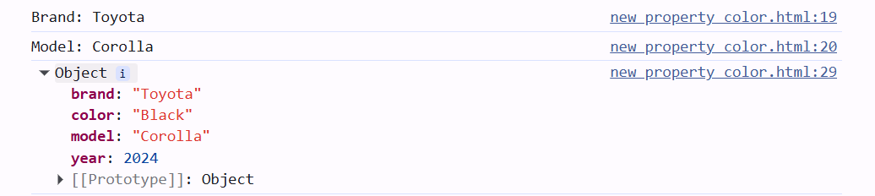
JavaScript Events
Lab Assignment
• Task: • Create a simple webpage with a button that, when clicked, displays an alert saying "Button clicked!" using JavaScript event listeners.
Ans:- 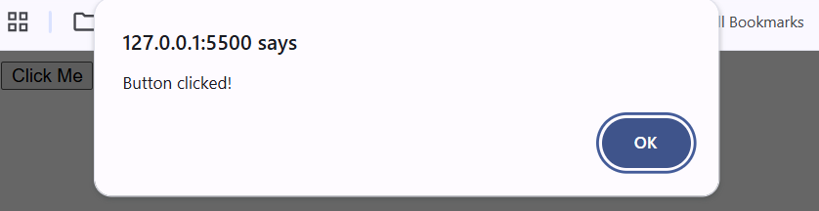
DOM Manipulation
Lab Assignment
• Task: • Create an HTML page with a paragraph () that displays "Hello, World!". • Use JavaScript to: • Change the text inside the paragraph to "JavaScript is fun!". • Change the color of the paragraph to blue.
Ans:-
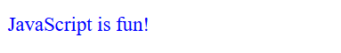

JavaScript Timing Events (setTimeout, setInterval)
Lab Assignment
• Task 1: • Write a program that changes the background color of a webpage after 5 secondsusing setTimeout().
Ans:-

• Task 2: • Create a digital clock that updates every second using setInterval()
Ans:-
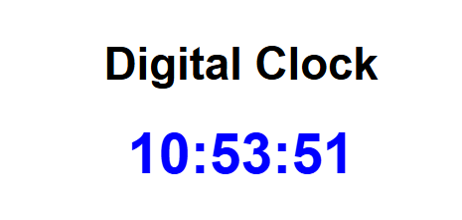
JavaScript Error Handling
Lab Assignment
• Task: • Write a JavaScript program that attempts to divide a number by zero. Use trycatchto handle the error and display an appropriate error message.
Ans:-
